Build a Serverless Website

Steps:

1. Create S3 Bucket by enabling ACLs

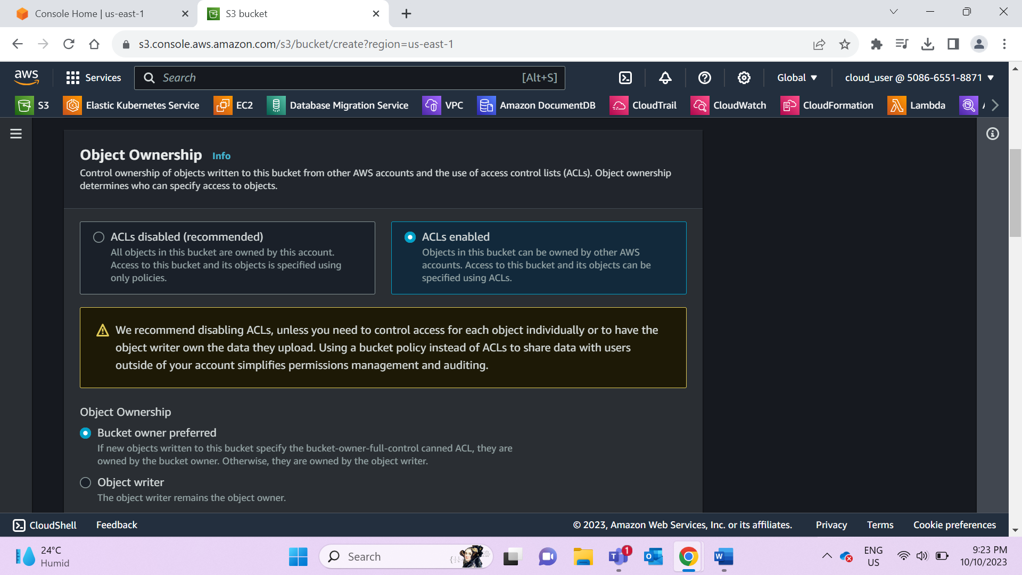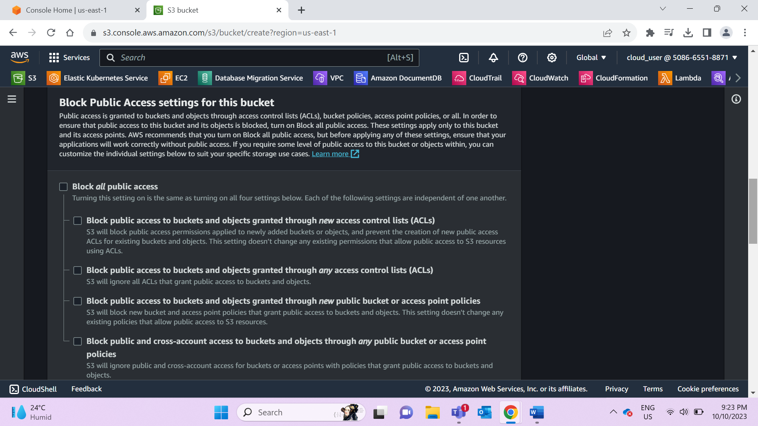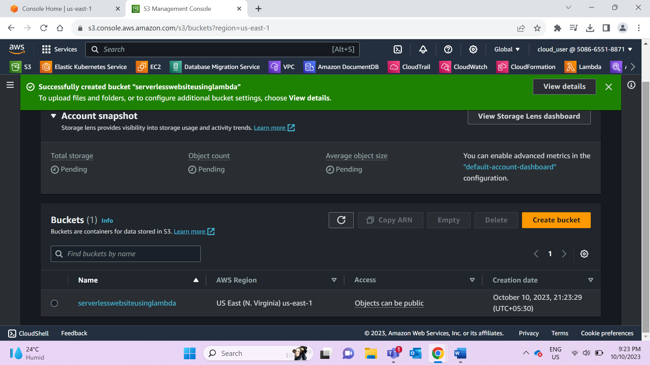

1. host static website under permission tab

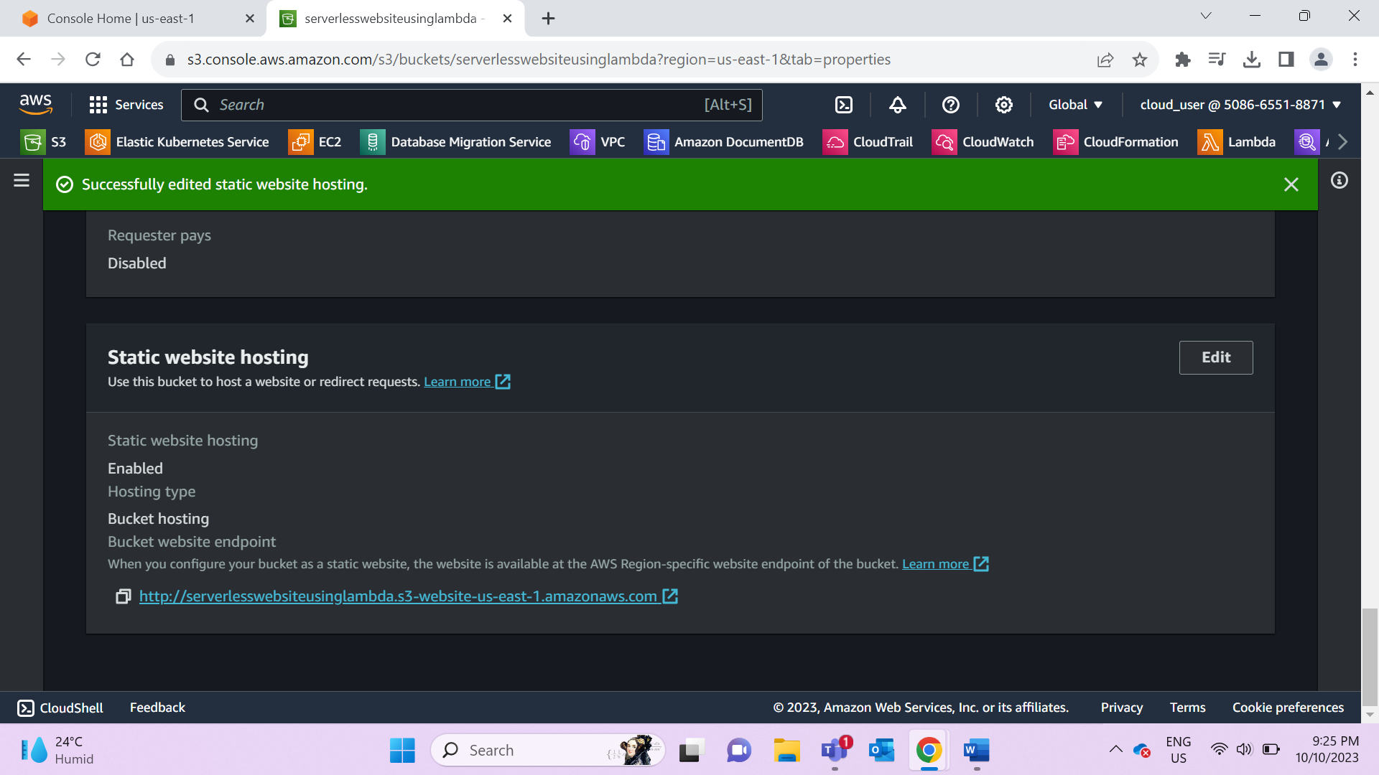

1. Create lambda and attach s3readaccess role

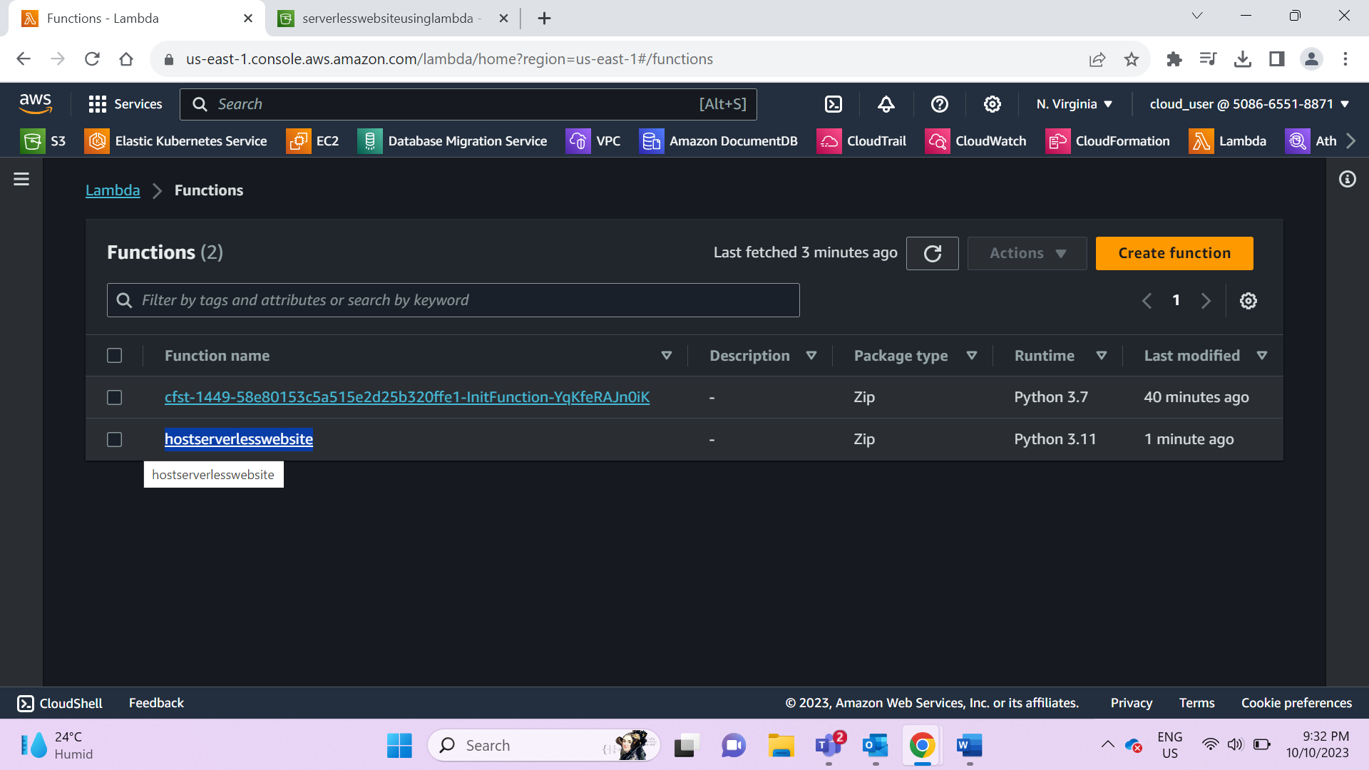

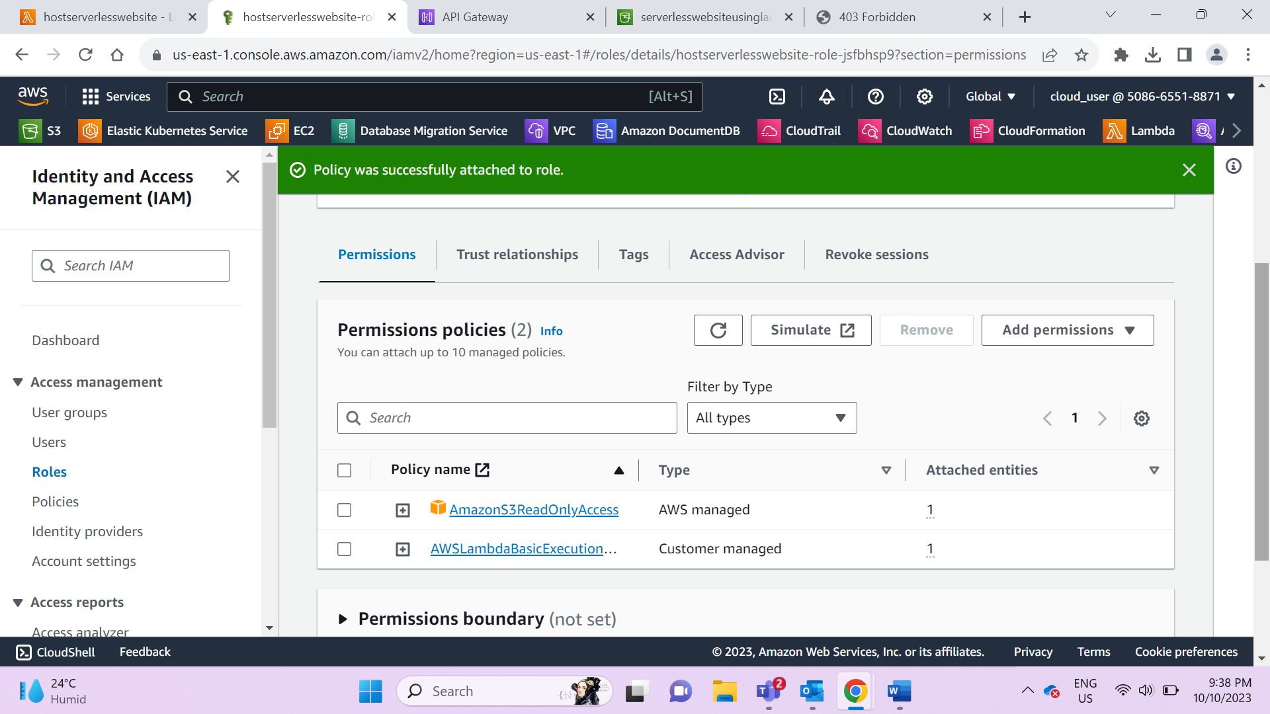

1. Create trigger as APIGW in lambda (Note: enable CORS without which serverless website wont work)

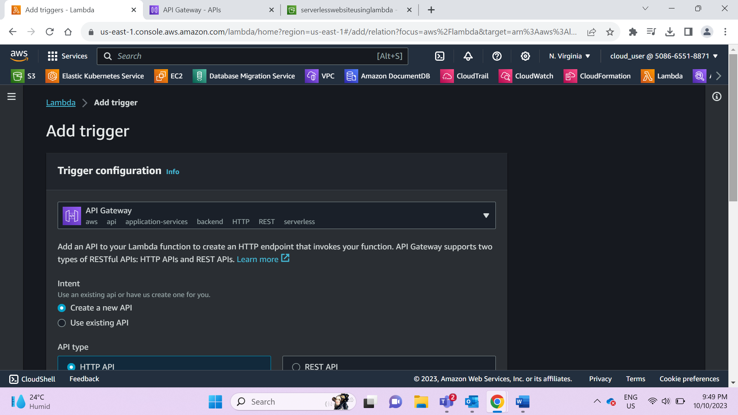

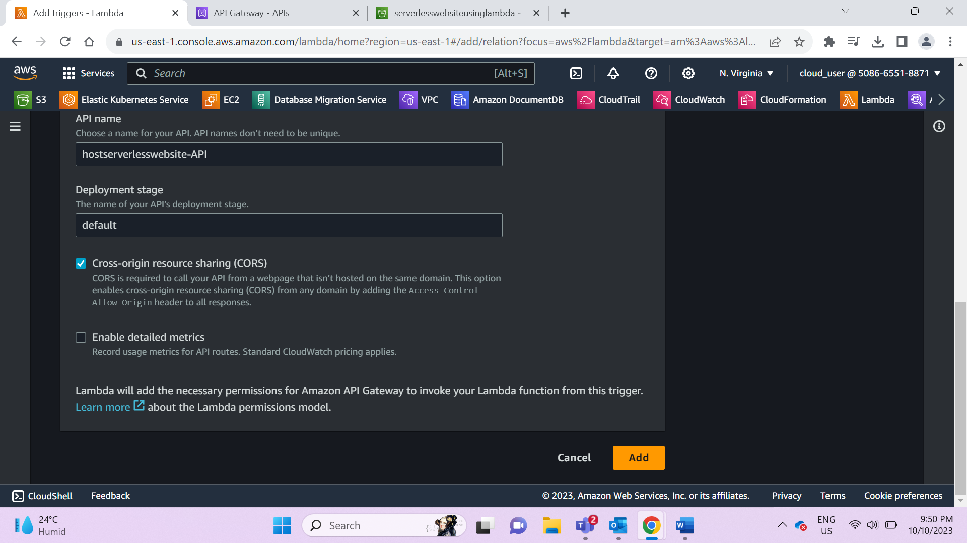

1. Host URL from triggers under lambda to check if the lambda is working

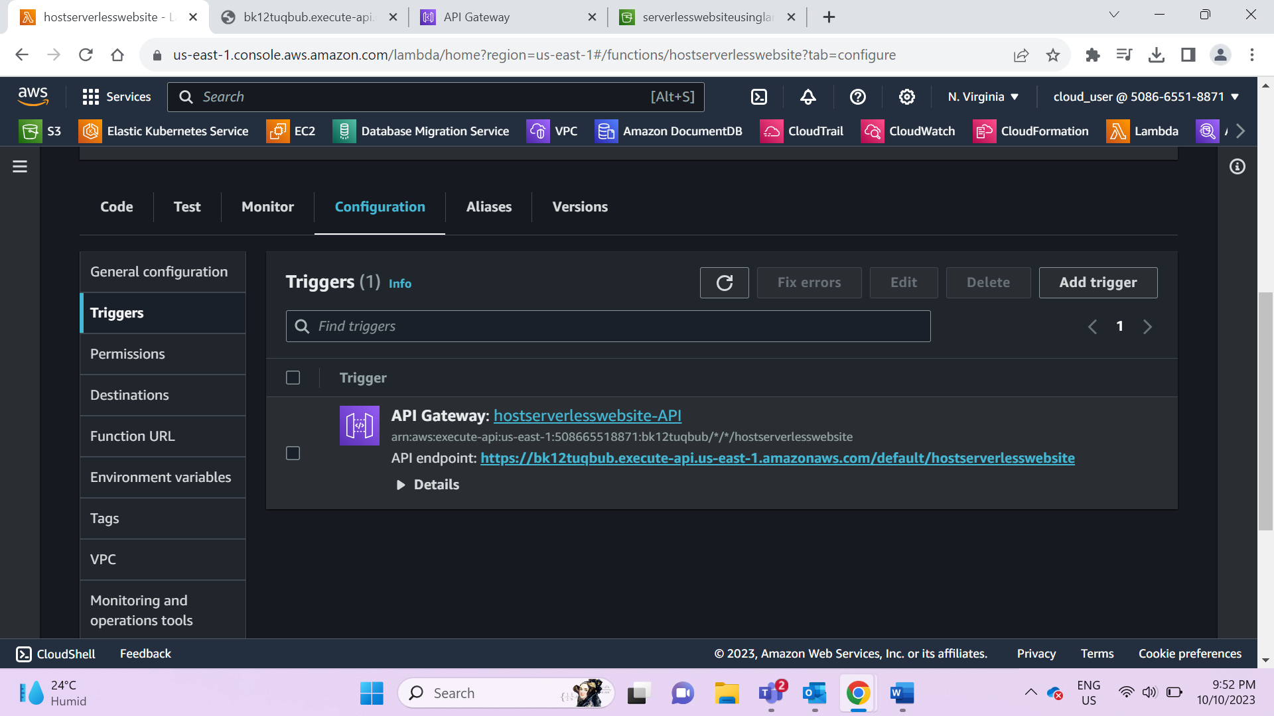

1. Update APIGW URL in index file before loading
2. Upload index & error files to S3; while uploading files enable public access to those files(otherwise you get 404 forbidden access)

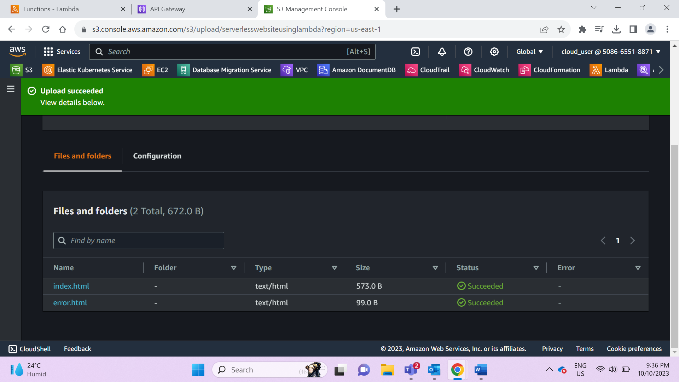

1. After clicking on static website link

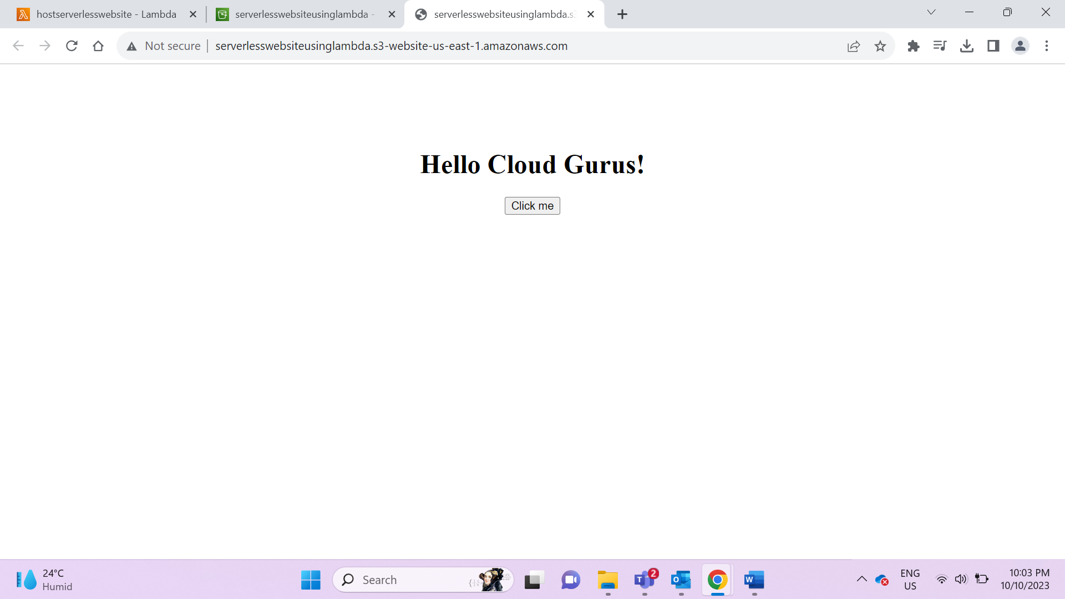

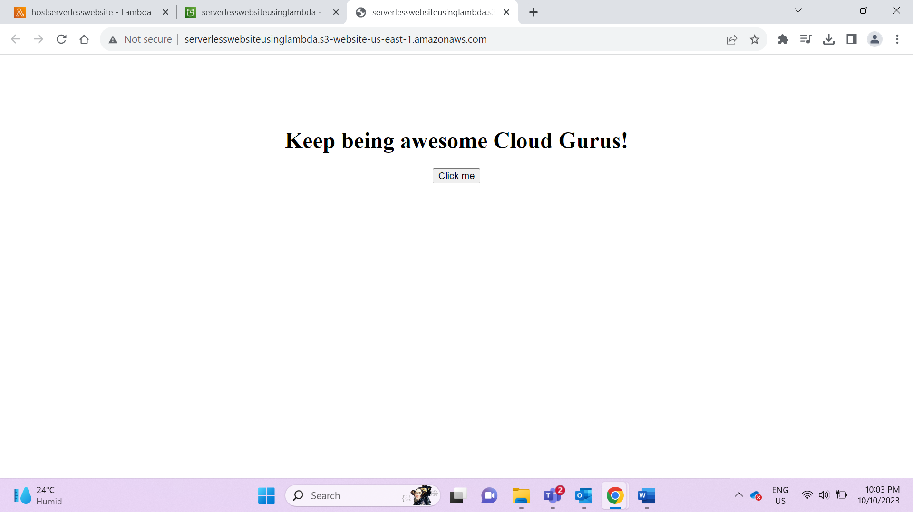

Code:

def lambda_handler(event, context):

print("In lambda handler")

resp = {

"statusCode": 200,

"headers": {

"Access-Control-Allow-Origin": "*",

},

"body": "Keep being awesome Cloud Gurus!"

}

return resp